Quest:-1 What is software? What is software engineering?

Ans: - Software is a set of instructions, data or programs used to operate computers and execute specific tasks. It is the opposite of hardware, which describes the physical aspects of a computer.

Software is a collection of codes, documents, and triggers that does a specific job and fills a specific requirement.

Engineering is the development of products using best practices, principles, and methods.

Quest:-2 Explain types of software.

Ans:- Among the various categories of software, the most common types include the following:

1)Application software. The most common type of software, application software is a computer software package that performs a specific function for a user, or in some cases, for another application

* + - Examples of modern applications include office suites, graphics software, databases and database management programs, web browsers, word processors, software development tools, image editors and communication platforms.

2) System software. These software programs are designed to run a computer's application programs and hardware. System software coordinates the activities and functions of the hardware and software

* + - Other examples of system software include the firmware, computer language translators and system utilities.

3) Driver software. Also known as device drivers, this software is often considered a type of system software. Device drivers control the devices and peripherals connected to a computer, enabling them to perform their specific tasks. Every device that is connected to a computer needs at least one device driver to function.

* + - Examples include software that comes with any nonstandard hardware, including special game controllers, as well as the software that enables standard hardware, such as USB storage devices, keyboards, headphones and printers.

4) Programming software. Computer programmers use programming software to write code. Programming software and programming tools enable developers to develop, write, test and debug other software programs.

* + - Examples of programming software include assemblers, compilers, debuggers and interpreters

Quest:-3 What is SDLC? Explain each phase of SDLC

Ans:- SDLC Meaning (Software Development Life Cycle)

An SDLC (software development life cycle) is a big-picture breakdown of all the steps involved in software creation (planning, coding, testing, deploying, etc.). Companies define custom SDLCs to create a predictable, iterative framework that guides the team through all major stages of development.

PHASE of SDLC

1) Requirements Analysis

Purpose: Create an overview of the project, determine requirements, and set the product groundwork

Key personnal: Business analysts.

Output:An SRS document that define project goals and needs

2)Feasibility Study:

Purpose:Evaluate whether the requirements analysis aligns with business goal and resources

Key personnal:Team leads and higher management

Output:An expanded SRS document approved by a decision-maker

3)Design Plan

Purpose: Design the upcoming product (architecture, UI, features, security measures, etc)

Key personnal:Architects and senior developers

Output: A detailed DDS document that explains how to code the product.

4)Software Development

Purpose: Translate the system design into sources code and build the first version of the product

Key personnal:Developers

Output: Testable, fully functional Software.

5)In-Depth Software Testing

Purpose: Ensure the product has no bugs or exploits and that it is in line with DDS expectations

Key personnal:All levels of testers.

Output: A thoroughly testes version of the product.

6)Software Deployment

Purpose: Push the new product into production by gradually phasing it into use.

Key personnal:Deployment engineers.

Output: The release of a fully functional and tested product.

7)Maintenance and Enhancement

Purpose: Keep the product safe and at optimal performance, plus occasional add new features.

Key personnal:Production support engineers, testers and developers

Output: A fully monitored product that's continuously seeing improvements

Quest 4:- What is DFD? Create a DFD diagram on Flipkart

# Ans :- Data Flow Diagrams

# A Data Flow Diagram (DFD) is a traditional visual representation of the information flows within a system. A neat and clear DFD can depict the right amount of the system requirement graphically. It can be manual, automated, or a combination of both. It may be used as a communication tool between a system analyst and any person who plays a part in the order that acts as a starting point for redesigning a system. The DFD is also called as a data flow graph or bubble chart.

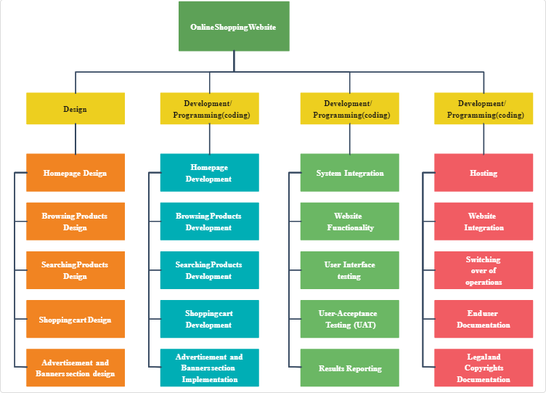

Quest 5:- What is Flow chart? Create a flowchart to make addition of two numbers

Ans: - A flowchart is **a diagram that depicts a process, system or computer algorithm**. They are widely used in multiple fields to document, study, plan, improve and communicate often complex processes in clear, easy-to-understand diagrams.

